YARN MITOSIS

ACTIVITY:
Move the yarn pieces on your desk to represent each step of mitosis. After practicing all the phases, quiz each other by naming different phases and creating them on your desks.
INTERPHASE: (IN between dividing)
Set up cell membrane on desk (Use black string to make a big oval on the desk).
DNA will switch back and forth between chromatin (long) and chromosomes (short) pieces during the activity.
In interphase DNA is spread out as chromatin. Cells start with 6 chromosomes.
(Count out 3 long purple and 3 long green strings and place in center of cell)
Nuclear membrane is visible (Place pink yarn piece around the DNA)
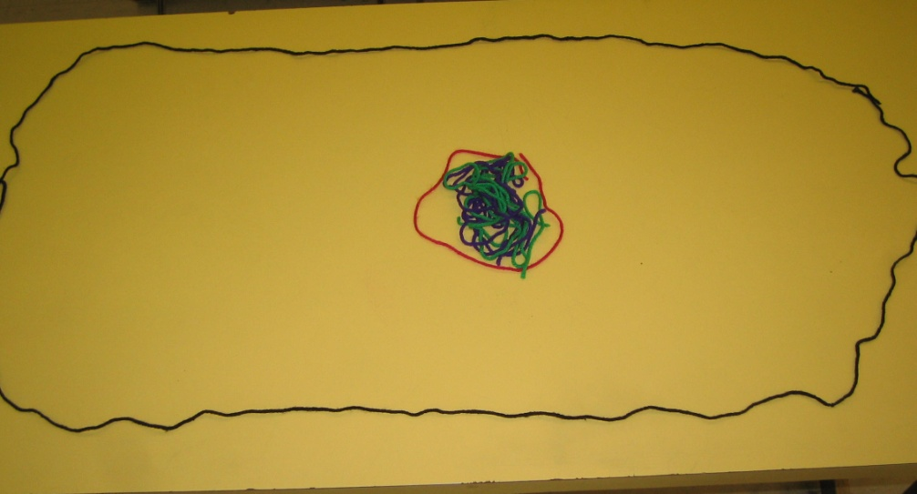
Image by Riedell
During S phase DNA is copied. Hold up each chromatin yarn piece and place a "copy" along side of it.
(Use the 3 extra long purple/green strings)
Replace DNA in nucleus
PROPHASE: (First dividing phase- Pros are #1)
Chromatin condenses into chromosomes (Replace longer yarn pieces in nucleus with shorter ones)
Remember to keep the chromatid "copies" together.
Nucleus/nucleolus disappears. (Remove pink yarn piece around chromosomes)
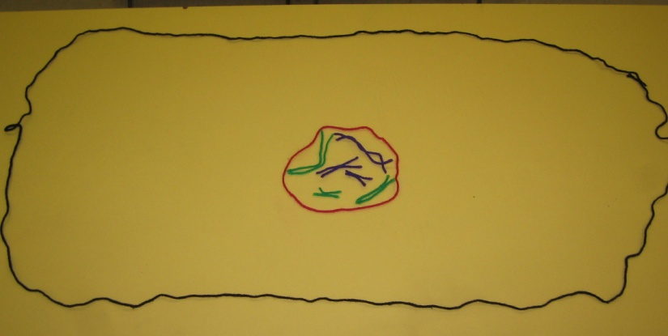 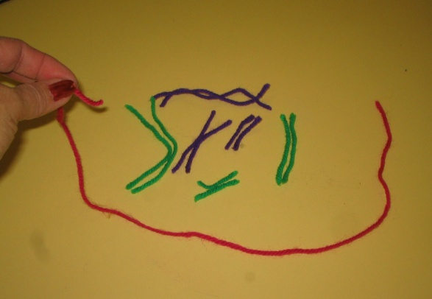
Images by Riedell
Centrioles/Spindle appear (play role of spindle with your fingers)
METAPHASE (MIDDLE)
Chromosomes line up in middle of cell. {Spindle (fingers) move chromosomes to middle of cell}
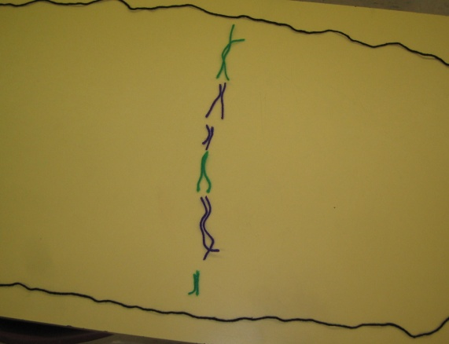
Image by Riedell

ANAPHASE (APART)
Chromatid arms separate and move to opposite ends of cell (Use fingers to separate chromatid arms)
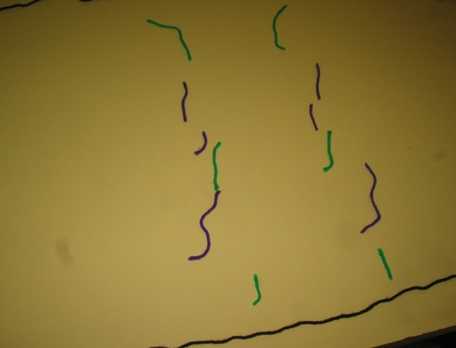
Image by Riedell
TELOPHASE (TWO NUCLEI)
Count chromosomes. You started with 6 (3 large, medium, small purple & 3 large, medium, small green)
How many does your cell have now? (Should have 3 purple and 3 green; check to make sure you have one L, M, S purple and one L, M, S, green)
Images by Riedell
Chromosomes spread back out into chromatin (Replace short yarn pieces with longer yarn pieces)
Nucleus/nucleolus return (Put pink string around each set of chromosomes.)
Spindle/centrioles disappear.
CYTOKINESIS (Cytoplasm splits)
Animal cells use a cleavage furrow.
(Push cell membrane together in middle to make two cells)
Plant cells make a cell plate
(Use orange string to make a wall instead of pinching)

