CHAPTER 7 CELL STRUCTUE AND FUNCTION CARD REVIEW
Complete using your answer sheet

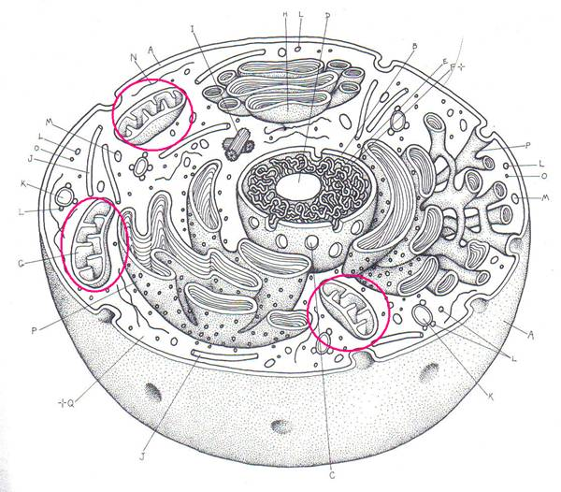 | #1. Name this organelle.  #2. Give the function for #1.

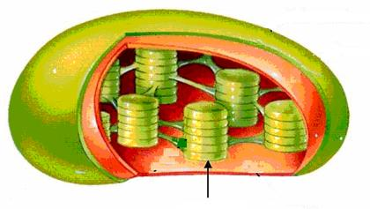 | #3.These membrane sacs are called _________.

#4. These integral proteins found in cell membranes help in identification. | 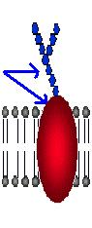
#5. Name this organelle.
#6.
Tell the polysaccharide found in PLANT CELL WALLS that makes them sturdy.
#7.
Membranes that allow certain substances to pass through, but keep other out are said to be SELECTIVELY____________
#8.The folded membranes inside a mitochondrion are called ________.
#9. The DNA and attached proteins that is SCRUNCHED UP in DIVIDING cells is called ______________
#10. The PROTEINS that are used to make the cytoskeleton, cilia, flagella, and centrioles are called ___________________.

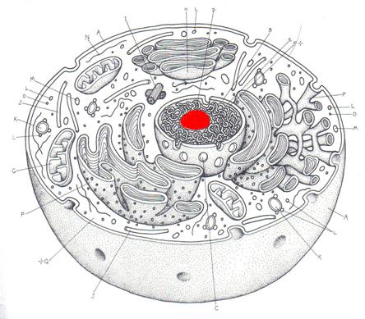 | #11. Name this organelle.  #12. Give its function

#13. Ribsomes can be found attached to_____________.
#14. Membrane proteins that stick into the cell membrane either part way or all the way through are called ______________ proteins.
#15. PHOSPHOLIPIDS and ___________ are the two main molecules that make up cell membranes.
#16. ____________ are the smallest kind of cell.
Plant cells Animal cells Bacterial cells

#17. The gel-like fluid and the organelles it contains which is found inside the cell membrane is called ____________________.
#18. An organism with a nuclear membrane and membrane bound organelles is called a _________________.
#19. Name the 2 organelles BESIDES THE NUCLEUS that have a DOUBLE MEMBRANE AND their OWN DNA.
#20. Name an organelle that has this arrangement of microtubules. | 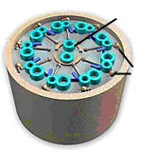
#21. Name a part found in plant cells but not animal or bacterial cells.
#22. Which part acts as the UPS of the cell to sort, modify, and package molecules for storage or transport out of cell?
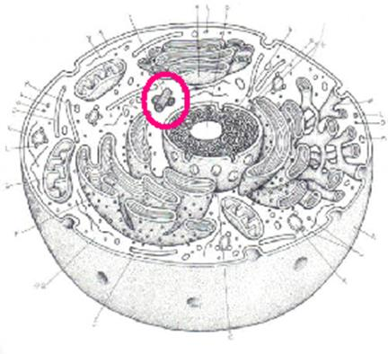 | #23. Name this part.  #24. Tell what it does.
#25. Name a kind of cell that is a EUKARYOTE.
#26. Tell one way animal cells are different from bacterial cells.

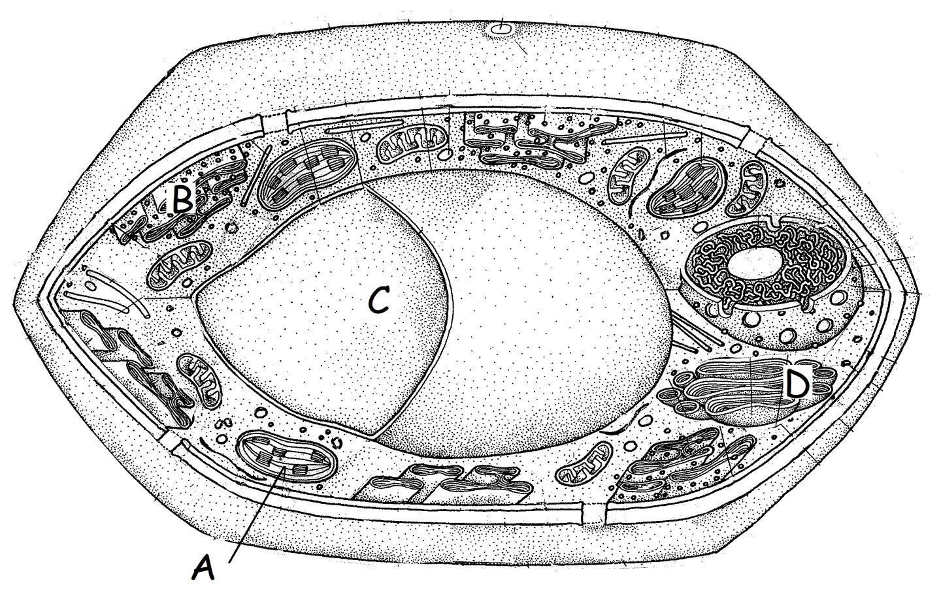 | #27. Name A.  #28. Give its function.

#29. Name C
#30. Tell something that might be found inside C.

#31. Tell one way cilia are different from flagella.

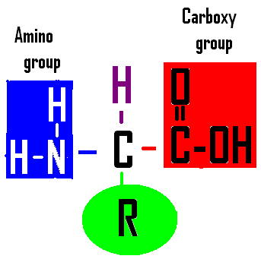 | #32. Name the cell part that uses this molecule.

