Name: ____________________________

BIOMES

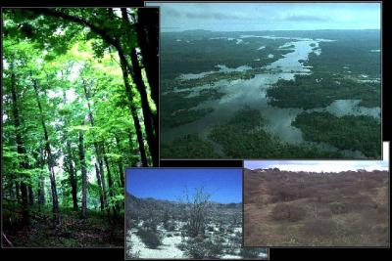
A biome is a large geographical area of distinctive plant and animal groups, which are adapted to that particular environment. Unfortunately, the various biomes on our planet are in danger due to human action (and inaction)! You will be learning a little about six biomes and choosing one to research in detail:
- freshwater
- marine (including coral reef)
- forest (deciduous, boreal, or rain forest)
- desert
- grassland or prairie
- tundra

Your task will be to research one of the six biomes and develop a proposal for what humans can do to help save that habitat before it's too late! Your plan (presented via Power Point) will need to include the six elements below, as well as pictures for each, and list of websites or other resources you used to gather information.
- Geographical location(s) (include map)
- Climate (typical temperature and rainfall)
- Plant life and its adaptations (what about the plants makes them suited for this biome?)
- Animal life and their adaptations (might require an educated guess on your part)
- Dangers or threats to the biome (man-made or other)
- Interventions that humans can make to preserve it**
- Once you and your partner have a biome, you may begin researching it. You are welcome to use a Search engine to gather information (no Wikipedia). Don't forget to write down the websites/sources you use to collect information.
- Once you have collected your data, you may begin creating your presentation.
- Your completed presentation must be saved on a flash drive (you can save it directly to the teacher's flash drive or, if you save it to your own, you must have it with you the day you present).

You will be scored according to the following rubric.
Evaluation Rubric
 | Unacceptable (4) | Minimal (6) | Fair (8) | Thorough (10) | Score
Geographical Location & Climate | Neither are included in report | Elements are mentioned briefly but without explanation or pictures | Elements are explained thoroughly OR pictures/maps are included | Elements are explained thoroughly; AND maps/pictures are included to illustrate each | 10
Plant life and its adaptations | Not included in report | Only 1 of 3 of the following is included: 1. Representative list of plant life 2. Adaptations of plant life 3. Pictures of plant life | 2 of 3 elements in previous list are included. | All 3 elements in previous list are included. | 10
Animal life and their adaptations | Not included | 1 of 3 elements below are included: 1.Representative list of animal life. 2. Adaptations 3. Pictures | 2 of 3 elements in previous list are included. | All 3 elements in previous list are included. | 10
Dangers to Biome and Potential Interventions | Neither are included in report. | Elements are mentioned briefly but without explanation or pictures | Elements are explained thoroughly OR pictures are included | Elements are explained thoroughly; AND pictures are included | 10
Total Score: 40

