Name:________________________________________

Blood Crossword
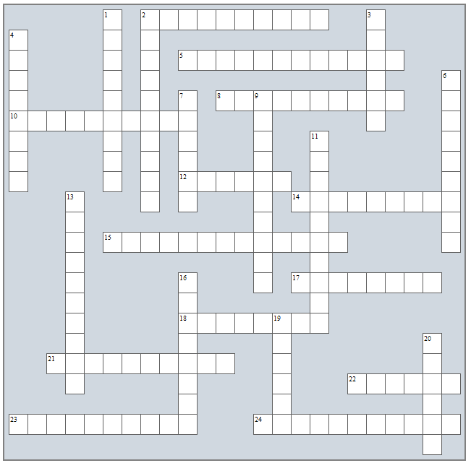

Down
- causes vasospasm
- "bleeder's disease"
- low red blood cell count
- cancer of the blood
- thrombocytes (common word)
- clear, liquid portion of blood
- cell that "eats" other cells
- circulate in body and attach to foreign substances
- the process where bleeding is stopped
- cell surface markers
- Movie: My ___ Valentine
- organ that breaks down old, worn out blood

Across
- binds to oxygen
- red blood cells
- percentage of blood cells and plasma in sample
- wbc that attacks parasites
- where new blood cells are created
- shape of a red blood cell
- clumping of blood cells from an immune response
- queen thought to be original carrier of hemophilia
- abnormal blood clot
- plasma protein that is converted to fibrin
- disease that causes rbc's to be abnormally shaped: __ Cell Disease
- white blood cells
- wbc's that produce antibodies

