Name_____________________________________Date:________________________

BONE MATRIX COLORING
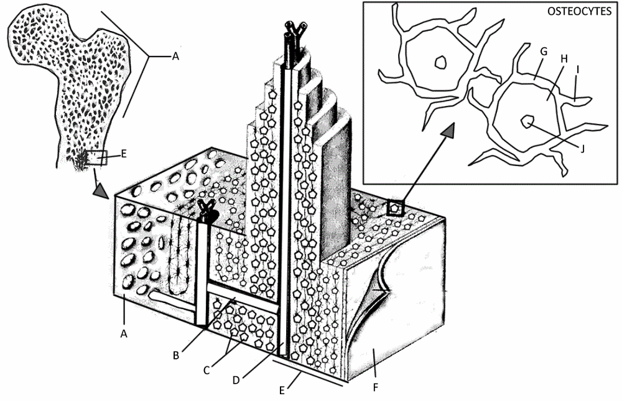

BONE COLORING KEY
Spongy Bone (A) - green
Volkman's Canal (B) - orange Osteocytes (C) - red
Haversian Canal (D) -- yellow
Compact Bone (E) -- leave white Periosteum (F) - pink

OSTEOCYTES
Lacuna (G) - blue
Osteocyte (H) - red
Canaliculi (I) - purple
Nucleus of Osteocyte (J) - gray

