Name:___________________________________Date:______________

Cell Cycle Labeling
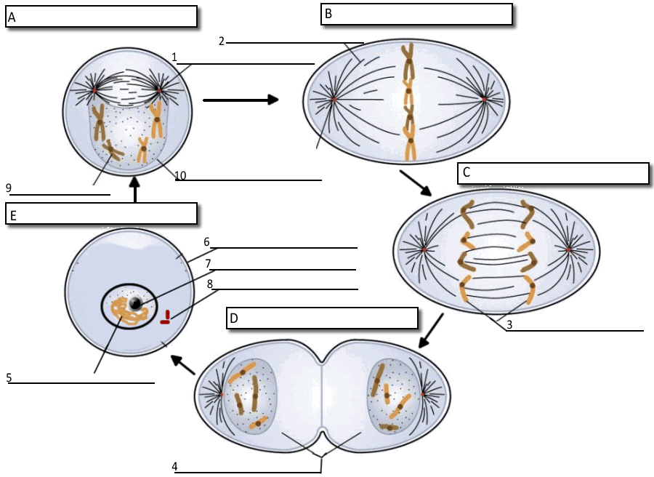
1. What moves the chromatids during mitosis? ___________________________________
2. What anchors the spindle? ________________________________________
3. What are the four phases of mitosis? ___________________________________________________
4. How many daughter cells are created from mitosis and cytokinesis? ___________________________
5. During what phase does cytokinesis begin? ________________________________________
6. If a human cell has 46 chromosomes, how many chromosomes will be in each daughter cell? _________
7. If a dog cell has 72 chromosomes, how many daughter cells will be created during a single cell cycle? ______.....Each of these daughter cells will have how many chromosomes? ____________
8. The nuclear membrane dissolves during what phase? ________________________
9. In the cell pictured above, how many chromosomes are present during prophase? ________________
10. What structure holds the individual chromatids together? ______________________________

