Name: ____________________________________

CONNECTIVE TISSUE MATRIX
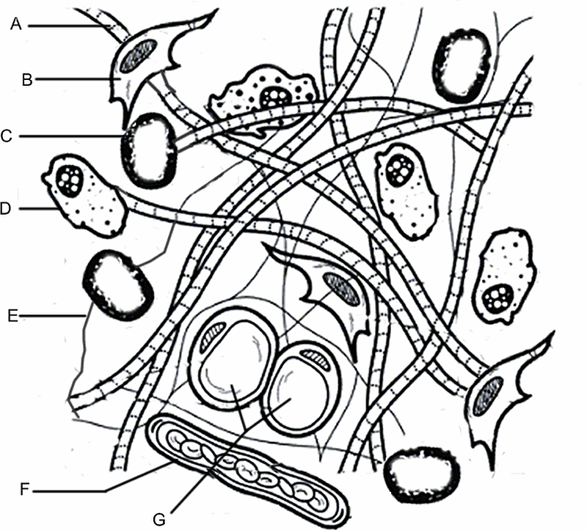
Match the structure to the function (use letters)
1. ____ Store energy
2. ____ Production of fibers
3. ____ Consume debris and foreign objects
4. ____ Fiber that makes up tendons
5. ____ Prevention of blood clots
Coloring Instructions
collagen fibers [A] yellow.
fibroblasts [B] blue.
mast cells [C] purple .
macrophages [D] orange
elastic fibers [E] green (shade over the line)
blood vessel and blood cells [F] red.
fat cells [G] pink.

