Name:________________________________________

Endocrine System Review and Wordsearch
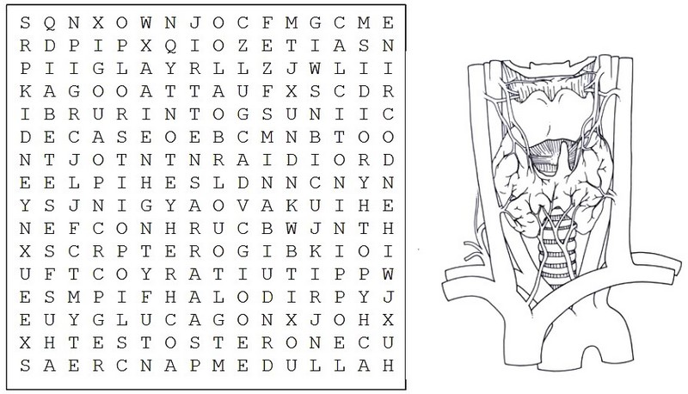
1. Gland in the brain that is the control center for all regulatory activities of the body: _________________________
2. Condition in which levels of thyroid hormones in the blood are very low: _________________________
3. Helps regulate when you sleep at night and when you wake in the morning ___________________________
4. Master gland, makes hormones that control several other endocrine glands ___________________________
5. Hormone that reproductive glands produce for females: _________________________________
6. Two hormones produces by the pancreas: _______________________ & _________________________
7. Gland produces hormones that control the rate at which cells produce energy _________________________
8. 4 tiny glands that function together that release hormones that regulates calcium levels: _________________
9. General name given to water soluble hormones (banned in most sports organizations ____________________
10. The inner part of the Adrenal gland: ______________________________
11. Hormone that reproductive glands produce for males: _________________________________
12. Gland that produces melatonin: ___________________________ body.
13. Causes milk production in nursing mothers and contractions during childbirth: _________________________
14. Increases blood pressure and heart rate when the body experiences stress: _________________________
15. Helps regulate calcium in the bones: _____________________________
16. Adrenal glands are located above this major organ: ___________________________
17. Disease caused by a failure of the body to produce insulin: _______________________________
18. Produced in the adrenal cortex, keeps blood glucose levels stable: ___________________________
19. Contains cells called the Islets of Langerhans: ________________________________
20. Collection of glands that secret chemicals that maintain homeostasis: _____________________ system

