**Label the Muscles of the Arm**

Arm (top side)

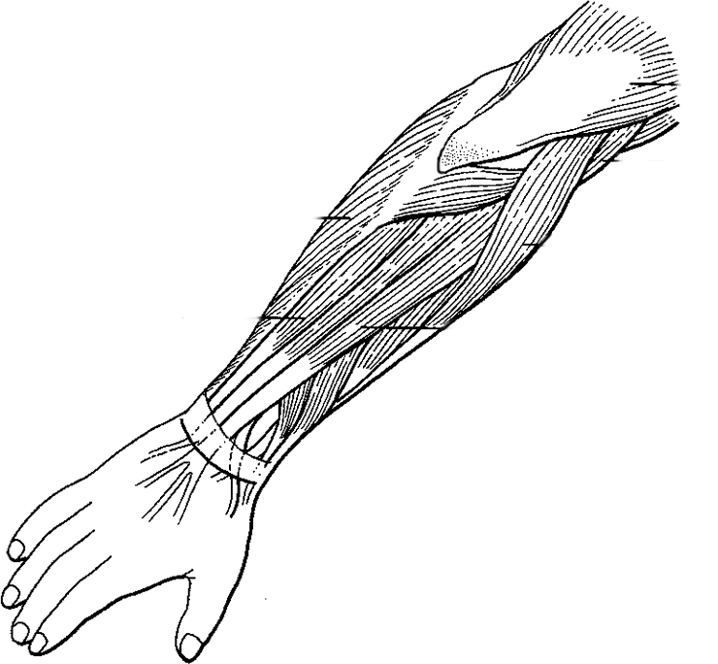

Arm (under side)

