Name________________________________________

Nerve Cells Coloring
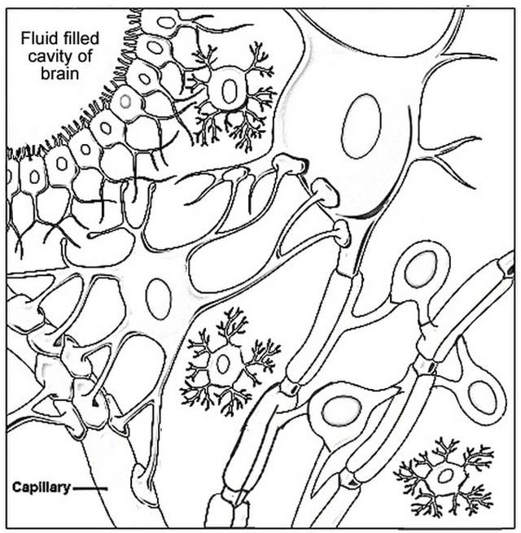

Oligodendrocytes (purple) Astrocyte (green) Ependymal Cells (orange) Body of Neuron (blue)
For each of the cells above, color the nucleus a darker shade of purple, green, blue, orange
Myelin sheaths (pink) Capillary (red)
Microglial cells (yellow) Nodes or Ranvier and the Axon (brown)
What is the function of:
1) Oligodendrocytes ____________________________________________________
_____________________________________________________________________
2) Astrocytes _________________________________________________________
_____________________________________________________________________
3) Microglial cells ______________________________________________________
_____________________________________________________________________
4) Myelin sheaths ______________________________________________________
_____________________________________________________________________
5) Trace the path of a nerve impulse in a neuron: _____________________________ _____________________________________________________________________

