Biology: Chapter 18 Name__________________________
Using Dichotomous Keys
Background: Scientists have developed an international system for naming and classifying all organisms. Identification guides, called keys, have been developed to help all peoples recognize and identify organisms according to their scientific names. Classification keys are usually dichotomous in arrangement. The word dichotomous comes from the word dichotomy, meaning “two opposite parts or categories.” A dichotomous key gives the reader a series of opposing descriptions of basic features of an organism. The reader studies the specimen and selects the descriptions that apply until reaching a statement that characterizes only one species of organism, and thus has identified it. In this investigation you will practice using a typical dichotomous key to identify tree leaves.
Dichotomous Key for Leaves
1---------a. Compound leaf (leaf divided into leaflets)
..............................................go to step 2
b. Simple leaf (leaf not divided into leaflets)
..............................................go to step 4

2---------a. Palmate arrangement of leaflets (leaflets
all attached at one central point)
.....................................Aesculus (buckeye)
b. Pinnate arrangement of leaflets (leaflets
attached at several points)
...............................................go to step 3

3---------a. Leaflets taper to pointed tips
..........................................Carya (pecan)
b. Oval leaflets with rounded tips
........................................Robinia (locust)

4---------a. Veins branch out from one central point
...............................................go to step 5
b. Veins branch off main vein in the middle
of the leaf...............................go to step 6

5---------a. Leaf is heart-shaped............Cercis (redbud)
b. Leaf is star-shaped
.........................Liquidambar (sweet gum)

6---------a. Leaf has toothed (jagged) edge
............................................Betula (birch) b. Leaf has untoothed (smooth) edge
.................................Magnolia (magnolia)

Skills: Observing and Classifying.
- Carefully observe the leaf labeled I in the diagram.
Decide which statement, 1a or 1b, applies to this leaf.
Then, follow the directions at the end of the statement.
- Continue reading the paired statements and following
the directions at the end of the applicable statement
until you determine the identity of leaf I.
- Repeat steps 2 and 3 for leaves II through VII.
- Record your steps as you complete each identification.
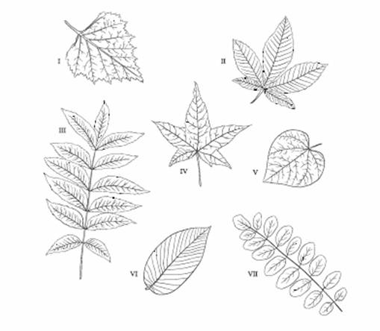

II.
I.

V.
III.

IV.

VII.
VI.

I. ____________________________________________________________
II. ____________________________________________________________
III. ____________________________________________________________
IV. ____________________________________________________________
V. ____________________________________________________________
VI. ____________________________________________________________
VII. ____________________________________________________________

