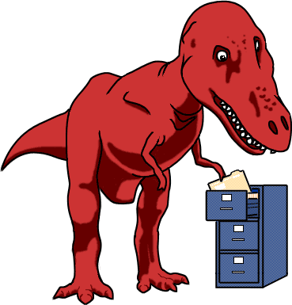

An introduction to how life is related

Go to http://www.ucmp.berkeley.edu/education/explorations/tours/Trex/index.html.
Click on “Student Start.” Next click on “Go to Beginning.”
Work through navigation skills. After this, work through folders 1-4 and complete the questions below.

Folder 1:
- Who did Thomas marry?

- How many children did Edward and Angelie have?

- Lineage might have been a new term for you. Which is the best definition for lineage?
- A single line showing age.
b) A continuous line of descent.
c) A set of parallel lines.

- Within this folder, you compared the history of a single family to the history of all life. What are some things that they have in common?
a) Both have a point of common ancestry.
b) In both, descendents inherit features from previous ancestors.
c) In both, descendents more closely resemble their recent ancestors than more distant ancestors.
d) All of the above.
e) None of the above.

Folder 2:

- What is the definition of a vertebrate.

- On the cladogram below, place a dot that represents the most recent common ancestor for B and C.

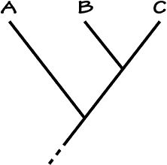

Folder 3:

- Which is more closely related to caimans—hares or parrots?
a) Hares
b) Parrots

- In the cladogram showing the shark, tuna, frog, human, hare, caiman, and parrot, what do the following letters represent:
a=
b=
c=
d=
e=
f=

- Which feature do humans, hares, caimans, and parrots share that the other three lineages did not inherit?
a) Bony skeleton
b) Hair
c) Amniotic egg

- Which of the tetrapods have an opening on their head other than those for eyes and nostrils?
a) Hare and crocodile
b) Frog and hare
c) Bird and crocodile

Folder 4:

- If we look at the skull opening in front of the eye — can we narrow down our search to two vertebrate lineages that might be most closely related to T. rex?
a) No, this feature does not help
b) Yes, the human and hare lineages
c) Yes, the caiman and parrot lineages

- Take a look at your table now that it's complete. Based on the features we have examined, who can we hypothesize that T. rex is most closely related to?
a) Parrots
b) Caimans

- What did T. rex taste like?
a) Chicken
b) Roast beef
b) Tuna

- Because T. rex was bipedal and had a reduced number of fingers, we can infer:
a) that T. rex was more closely related to birds than to crocodiles
b) that T. rex and birds inherited these features from a common ancestor
c) that T. rex probably shares more features with birds than with other vertebrates
d) all of the above
e) none of the above

